**DA62 Oxygen Pressure Gauge with Raspberry Pi Pico and 1.28-inch LCD Screen**

**(based on the XPLPro library for X-Plane)**

**Hardware:**

* Raspberry Pi Pico
  + <https://tinyurl.com/2h8rs7u3>
  + <https://tinyurl.com/4s2kzhkw>
* 1.28 in round LCD (GC9A01)
  + <https://tinyurl.com/cvtb823y>
  + <https://tinyurl.com/3nby3jny>
  + Note: If you want to use the simple case I designed, get the one with the specific form factor below.

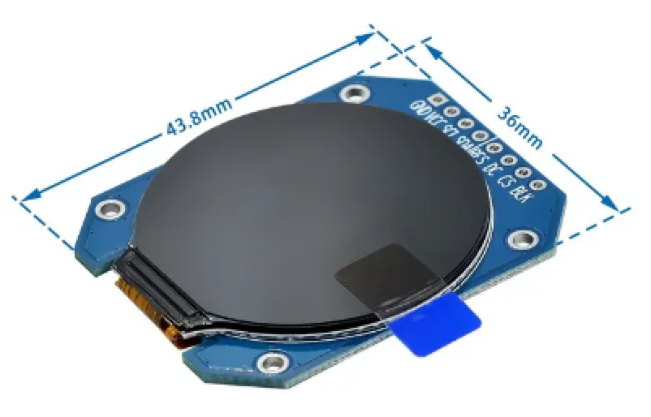

* USB connectors, wires, etc.
* Raspberry PI Pico and LCD Screen PIN connections

|  |  |
| --- | --- |
| LCD Screen PIN | Raspberry Pi Pico PIN |
| GND | GND |
| VCC | 3V3 |
| SCL | 18 |
| SDA | 19 |
| RES | 21 |
| DC | 20 |
| CS | 17 |
| BLK | 16 |

**Software:**

* XPLPro Plugin
  + Join the Curiosity Workshop Discord Server: <https://discord.com/invite/RacvaRFsMW>
  + Download the XPLPro Plugin and examples from the XPL/Pro channel under Downloads
  + Install the XPLPro plugin to X-Plane (I tested with X-Plane 11 and the May 10, 2024 release of the XPLPro Plugin)
* XPLPro references (FYI): https://www.youtube.com/watch?v=SMJiGwNc7rY&list=PLyhdwj5KOwbRhrUx4h9TRbHhn0aXaRivt
  + <https://www.youtube.com/watch?v=SMJiGwNc7rY&list=PLyhdwj5KOwbRhrUx4h9TRbHhn0aXaRivt>